Physical properties of rocks
1. Color
What color the rock looks like.
Example: black basalt (light to dark grey color) 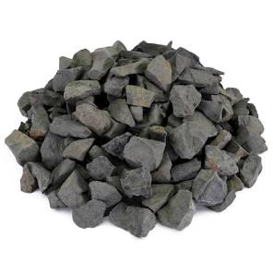
pink granite,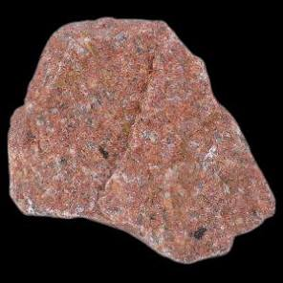
white limestone.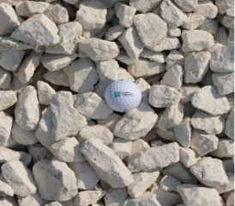.

Texture (grain size)
How the rock feels and how big the particles are.
Coarse – big grains you can see (granite)

Fine – tiny grains (basalt)

Glassy – shiny, smooth (obsidian)

Bubbly – full of holes (pumice)

3. Hardness

How hard it is to scratch the rock.
Scientists use the Mohs scale (1–10).
The Mohs scale is like a scratch test ladder for rocks and minerals.
The higher the number, the harder the mineral.
Number Mineral Easy way to remember
1 Talc Can scratch with fingernail easily
2 Gypsum Very soft
3 Calcite Scratched by a coin
4 Fluorite Soft but stronger
5 Apatite Medium hardness
6 Feldspar Scratches glass
7 Quartz Very hard
8 Topaz Hard gemstone
9 Corundum Ruby & sapphire
10 Diamond Hardest natural mineral 💎
⭐ Important rule

A harder mineral scratches a softer one.

Examples:

Quartz (7) scratches glass

Diamond (10) scratches everything

Easier explanation

The Mohs scale is like a scratch test ladder for rocks and minerals.
The higher the number, the harder the mineral. For example
Number Mineral Easy way to remember
1 Talc Can scratch with fingernail easily
2 Gypsum Very soft
3 Calcite Scratched by a coin

10 Diamond Hardest natural mineral
If you want, I can make a small classroom experiment for testing hardness 😊

Examples:

Fingernail scratches soft rocks

Knife scratches medium rocks

Hard rocks scratch glass

4️⃣ Luster

How the rock reflects light.

Shiny/metallic

Glassy

Dull

Waxy

5️⃣ Density (heaviness)

How heavy the rock feels for its size.

Pumice → very light (can float!)

Basalt → heavy

6️⃣ Streak

Color of the powder when rubbed on rough tile.
Sometimes different from the rock color.

7️⃣ Layers or patterns

Many rocks show:

stripes

layers

crystals

fossils

These clues tell how the rock formed.

Summary

Rocks can be described by their color, texture, hardness, luster, density, streak, and patterns.

